Lab: Implementing NameNode HA
Objective: | To configure and verify NameNode High Availability using Ambari.
Successful Outcome: | Your cluster will have a Standby NameNode along with Active NameNode.
Before You Begin: | Open the Ambari UI at [localhost]:8080

- Enable NameNode HA
  - Go to the Admin page and select High Availability. Click on Enable NameNode HA button.
NOTE: Depending on the Ambari release, High Availability may be located: HDFS>”Service Actions” tab>Enable NameNodeHA...
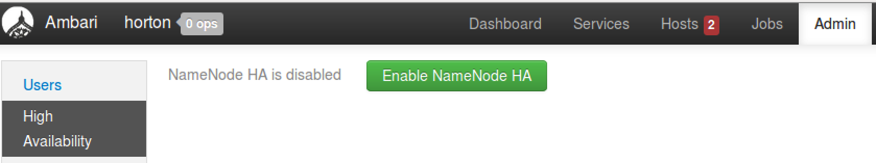
  - Enter HACluster as the Nameservice ID for your NameNode HA cluster. (The name must consist of one word and not have any special characters.) Click the Next button:

  - Choose the appropriate node as the Additional NameNode:
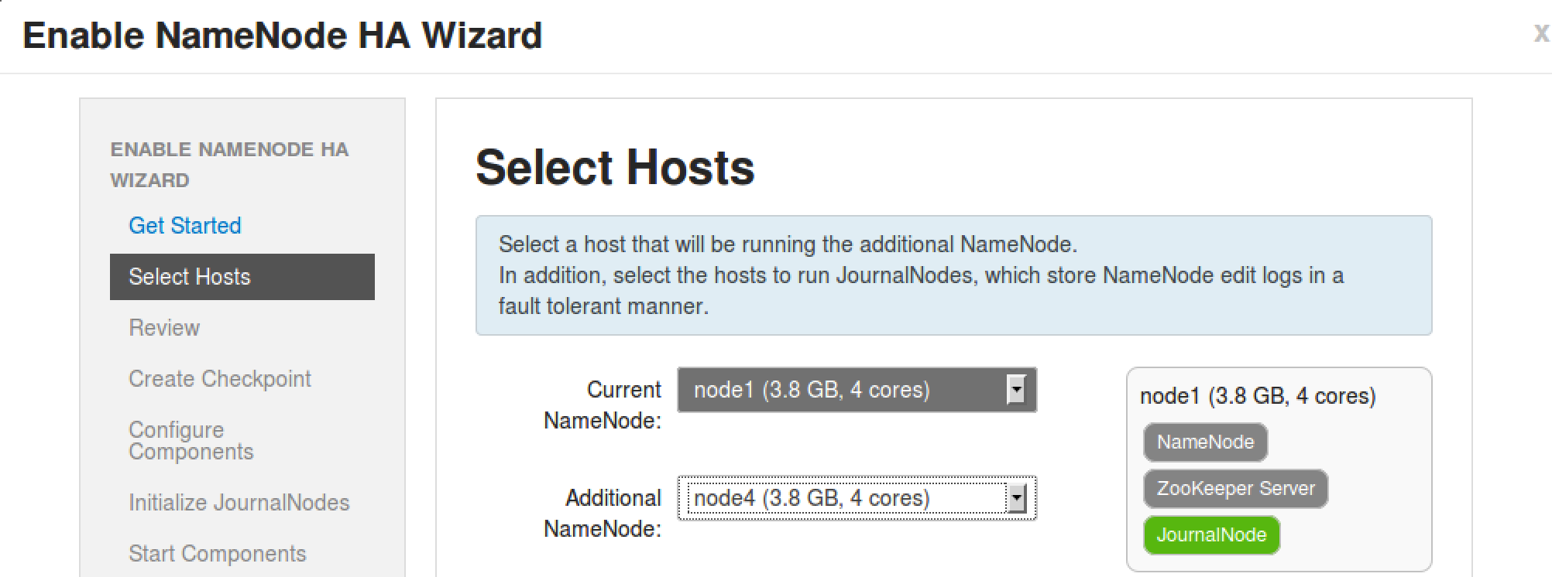
  - Click the Next button.
  - Notice that a Secondary NameNode is not allowed if you have NameNode HA configured. Ambari takes care of this for you, as you can see on the Review step of the wizard:
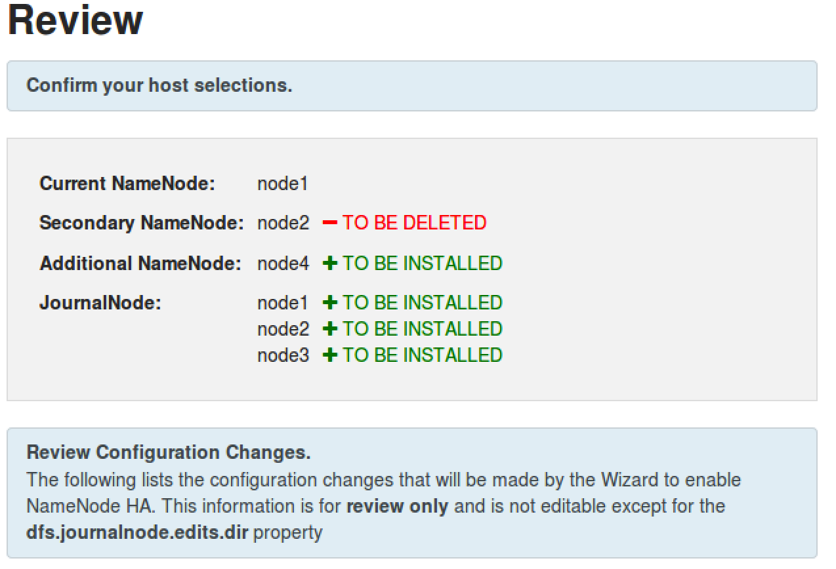
  - Review changes in the configuration and click the Next button to continue the wizard.
- Perform the Manual Steps
  - Notice the Enable NameNode HA Wizard is requiring you to perform some manual steps before you are able to continue.
  - Start by SSH-ing into NameNode.
  - Put the NameNode in Safe Mode:
# sudo su -l hdfs -c 'hdfs dfsadmin -safemode enter'
  - Create a Checkpoint:
# sudo su -l hdfs -c 'hdfs dfsadmin -saveNamespace'
  - Once Ambari recognizes that your cluster is in Safe Mode and a Checkpoint has been made, you will be able to click the Next button.
- Wait for the Configuration
  - At this point, Ambari will stop all services, install the necessary components, and restart the services. Wait for these tasks to complete:
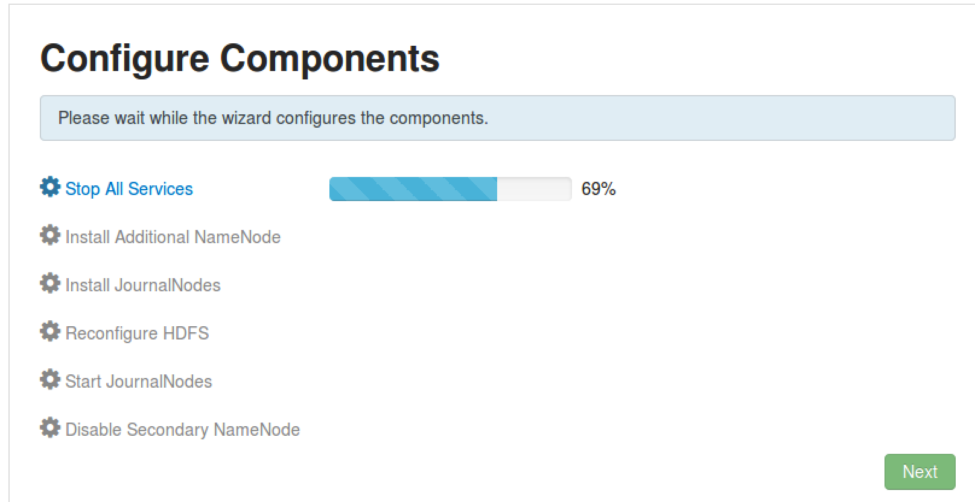
  - Once all the tasks are complete, click the Next button.
- Initialize the JournalNodes
  - On hadoop-master, enter the command shown in the wizard to initialize the JournalNodes:
# sudo su -l hdfs -c 'hdfs namenode -initializeSharedEdits'
  - Once Ambari determines that the JournalNodes are initialized, you will be able to click the Next button:
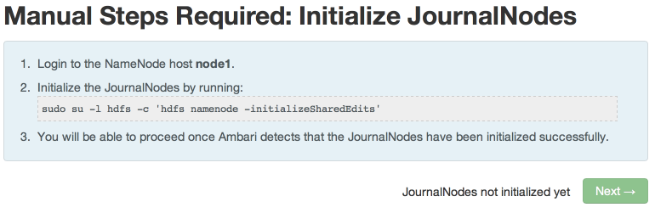
- Start the Components
  - In the next step, Ambari will start ZooKeeper and the NameNode service. Click Next when its complete:
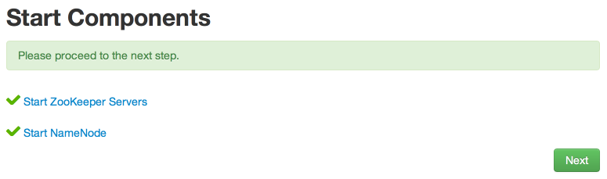
- Initialize NameNode HA Metadata
  - On hadoop-master, enter the command shown in the wizard to configure the metadata for automatic failover:
# sudo su -l hdfs -c 'hdfs zkfc -formatZK'
  - On one of your slave nodes, run the command to initialize the metadata for the new NameNode:
# sudo su -l hdfs -c 'hdfs namenode -bootstrapStandby'
  - Click the Next button to continue.
- Wait for the Wizard to Finish
  - In this final step, the wizard will start all required services and delete the Secondary NameNode:
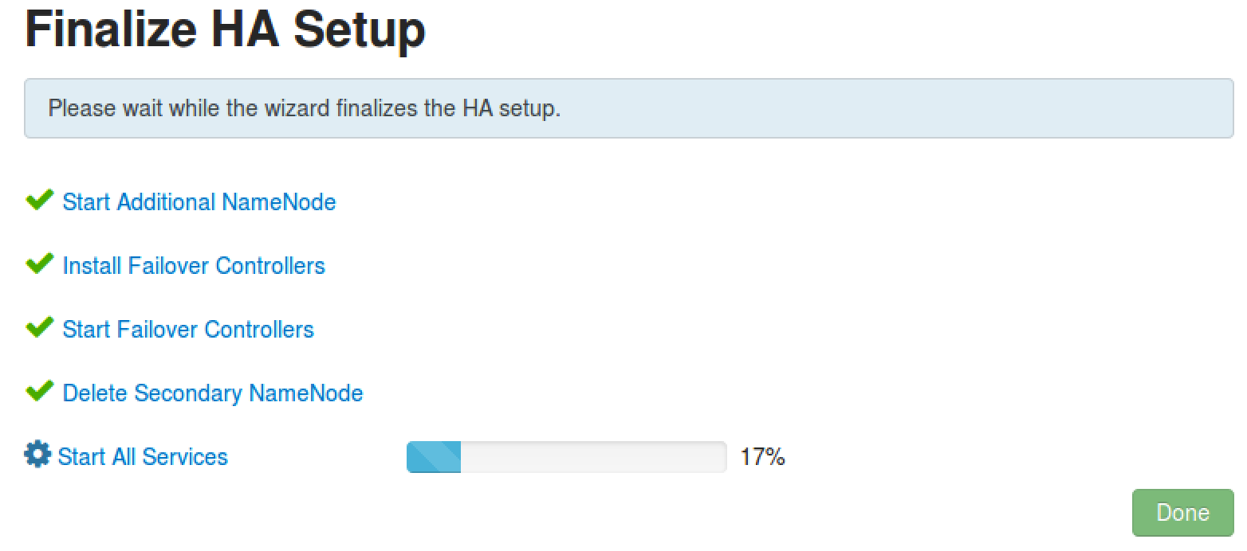
  - Click the Done button when all the tasks are complete.
- Verify the Standby NameNode
  - Go to the HDFS service page. You should see an Active NameNode and a Standby NameNode:


- Test NameNode HA.
  - Go the Host page of node1 in Ambari.
  - Next to the Active NameNode component, select Stop from the Action menu:
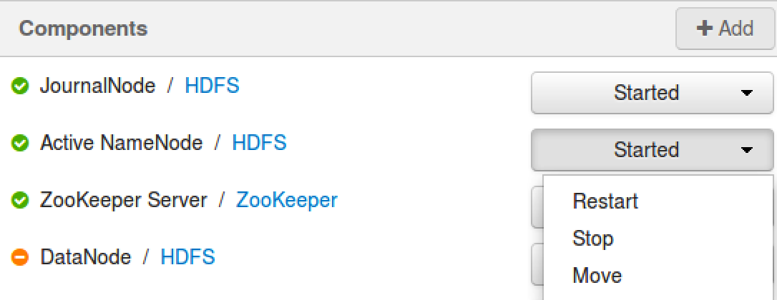
  - Go back the HDFS page in Ambari. Notice the Standby NameNode has become the Active NameNode:

  - Now start the stopped NameNode again, and you will notice that it becomes a Standby NameNode:


RESULT: You now have NameNode HA configured on your cluster, and you have also verified that the HA works when one of the NameNodes stops.

